https://github.com/NetCommons3/NetCommons3/wiki/Let%27s-Encrypt%E5%AF%BE%E5%BF%9C

Let's Encrypt対応
Mitsuru Mutaguchi edited this page on 16 Nov 2017 · 1 revision
https://github.com/NetCommons3/NetCommons3/blob/master/.htaccess
.htaccessを下記のように修正します。
<IfModule mod_rewrite.c>
RewriteEngine on
# /.well-known/ is Let's Encrypt
# Let's Encrypt need http(80) and DocumentRoot/.well-known/
RewriteCond %{REQUEST_URI} !(^/.well-known/)
RewriteRule ^$ app/webroot/ [L]
RewriteCond %{REQUEST_URI} !(^/.well-known/)
RewriteRule (.*) app/webroot/$1 [L]
</IfModule>
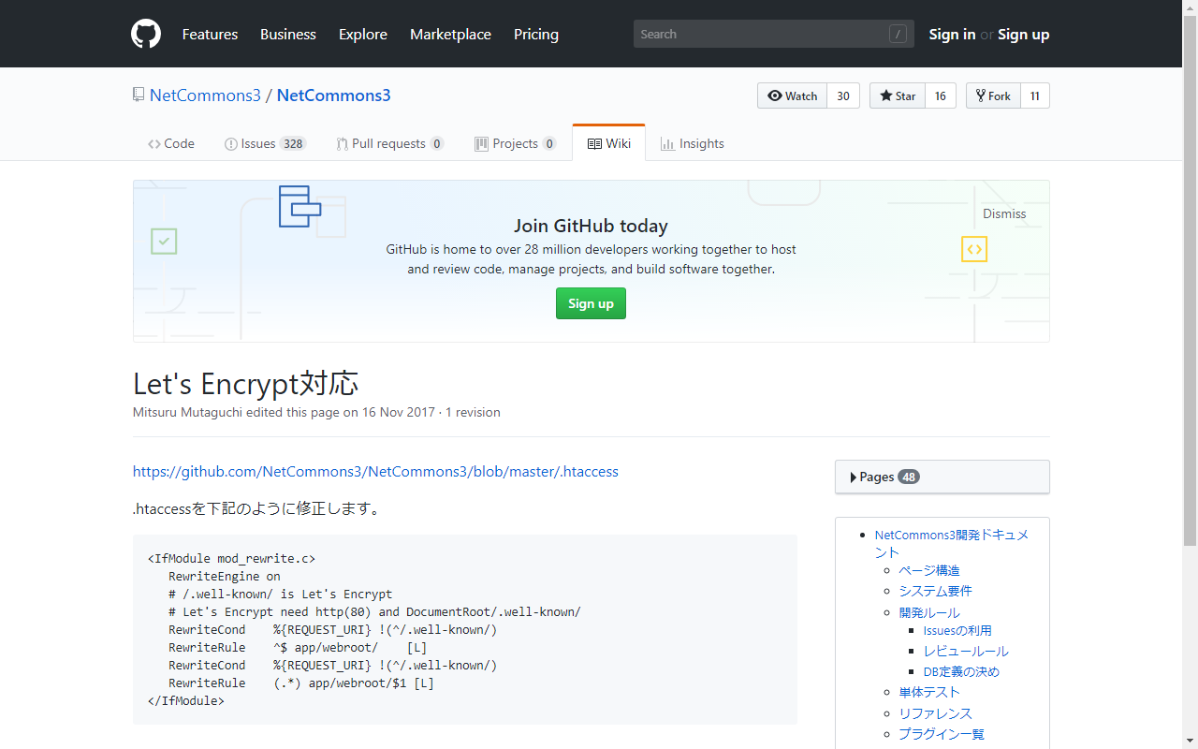
オリジナルの.htaccess
<IfModule mod_rewrite.c>
RewriteEngine on
RewriteRule ^$ app/webroot/ [L]
RewriteRule (.*) app/webroot/$1 [L]
</IfModule>

https://github.com/NetCommons3/NetCommons3/issues/1098
